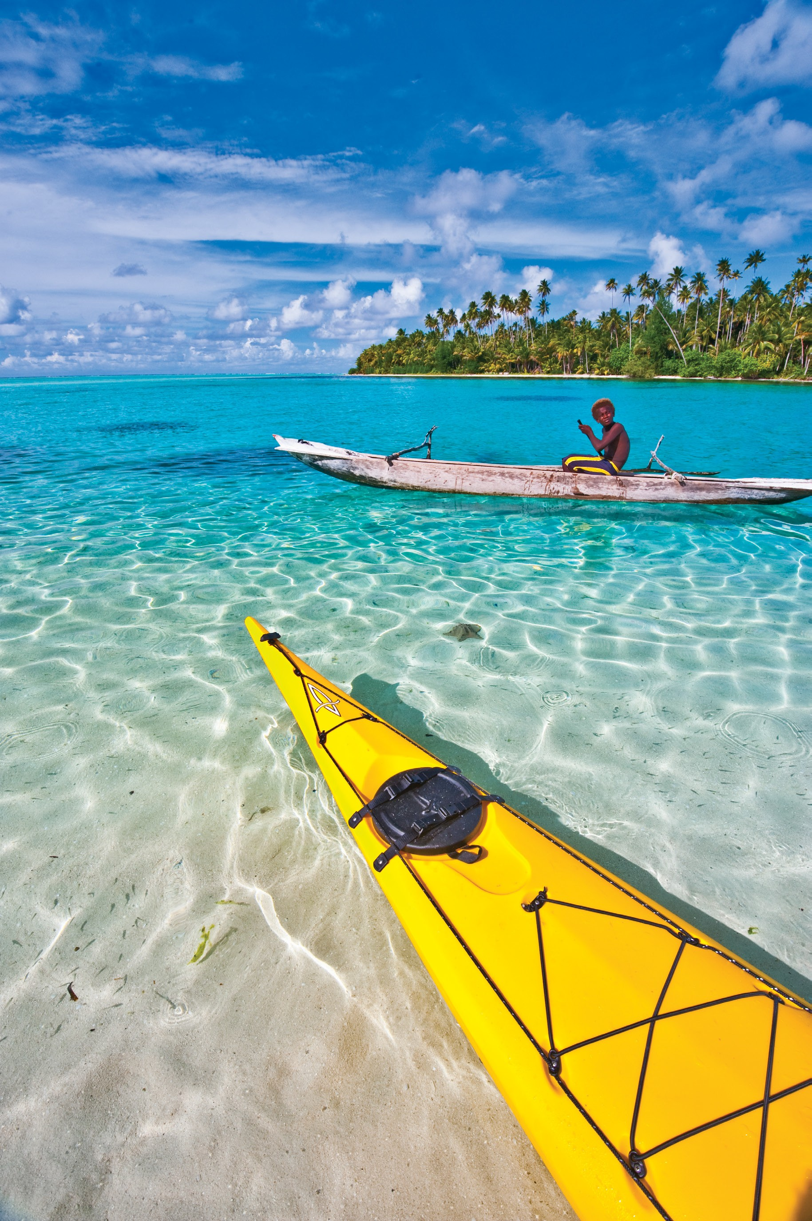5 Night Kayaking Expedition 2016

Inclusions:

Airfares - POM-Tufi-POM
2 night’s resort accommodation 3 night’s village accommodation
Set up / landowner / guide fees x 4 days Kayak hire x 4 days

USD$1,645.00
per person deluxe twin share

USD$1,715.00
per person deluxe single occupancy

Papua New Guinea remains vastly untouched by the modern world and is one of the last true frontiers for nature lovers, adventurers, and aquatic enthusiasts. Tufi is a remote pristine region located at the tip of Cape Nelson in Oro Province. The resort perched on the slopes of Mt Trafalgar is surrounded by lush tropical rainforest overlooking the picturesque fjords.

Contact Dive Discovery to book this amazing Kayak Adventure with local Village! If you are a diver, we can add extra time with amazing diving for divers!

Tel: (800) 886-7321, ph-(415) 444-5100 Fax: (415) 444-5560
Web: www.divediscovery.com email: Info2@divediscovery.com

